Humidity control setup 2015.02.27

- See attached PDF file for FSV setup and humidity sensor setup
- Work for both N2 and dry air
- Use 0-2.6V to control FSV proportional valve. FSV seems to fail when >3V.
- Use FSV TTL signal for fast shutter on/off control. It can be used to save gas by shutting off both valves and keep the humidity/oxygen levels (run the attached matlab code scpt_humidity_control.m on a separate matlab)
- FSV Wet valve setup
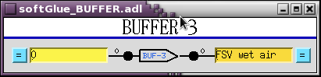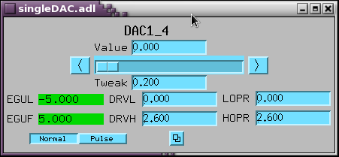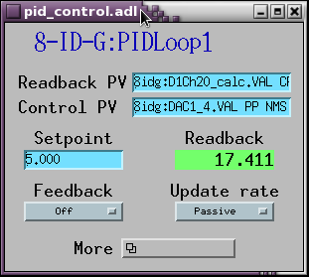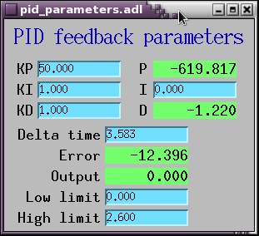
- FSV Dry valve setup: for negative control, use a register (Reg. 78) to invert the control voltage. Can also use negative KP values without the register for negative control.
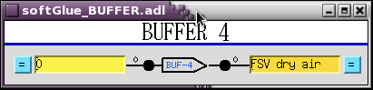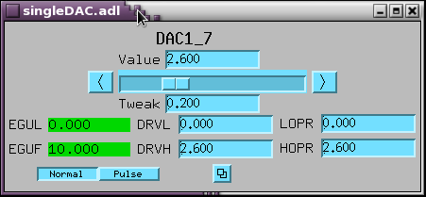
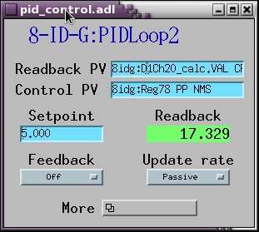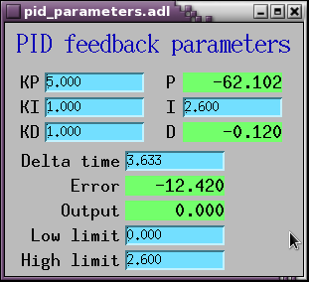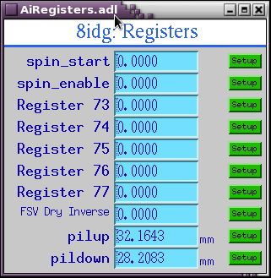
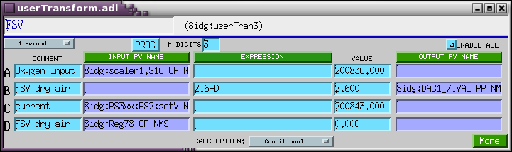
- Softglue setup for FSV TTL signals
- Humidity sensor setup. The sensor is mounted next to the sample.
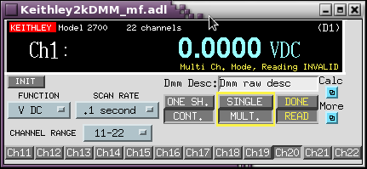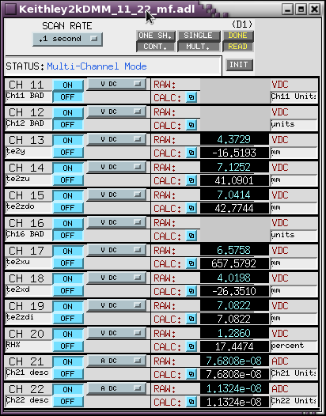
- Additional temperature sensor was mounted (with fabric tape) on top of the copper heat block to control the sample temperature.
- Bstop3 height is about 5-7 mm above the sample stage surface
- Oxygen sensor is in the chamber
- Humidity, oxygen level, and sample temperatures are written into spec file and pillog

