Guide For Filling Out an ESAF
Experimenters
- Limit the On-Site Spokesperson (OS) to one or two persons in charge of the experiment.
- All users who will be actively participating in the experiment should be listed as “On-Site”. All On-Site users must have all their training current before the start of beam time, except for sector orientation. Sector orientation will be updated at the beamline as necessary.
- “Observers” do not need any training, but must be escorted at all times by an On-Site experimenter whose training is current.
- People involved with the experiment but not coming to APS may be listed as “Off-Site”. They are not required to complete any training.
Description
- DO NOT CUT/PASTE THE PROPOSAL. The “science” behind your experiment has already been approved. The Description should cover all SAFETY aspects.
- Describe the logistics of the experiment with special emphasis on any hazard mitigation. i.e. How will samples be handled or manipulated; State the sample environment – vacuum or air, temperatures needed; Where will samples be prepared; What equipment will be used; What PPE is required; etc.
- Attach all relevant documents, if any – SOPs, manuals, SDS, etc.
Experiment Setup
- Describe any special equipment and/or requirements to setup your experiment.
- This may include a list of electrical items, unpacking of crates, Rigging needs, Hand tools used, etc.
Materials
- List all samples & chemicals that will be brought to and/or used at the APS. (See the Policy for Identification link on the Materials Tab)
- Include the CAS number from appropriate SDS.
- Check ALL appropriate boxes regarding known hazards.
- If the sample list consists of many similarly classified materials, they may be grouped together ONLY if all substantive elements (chemicals) and hazards are listed per group. – If this is the case it should be stated very clearly on the Description Tab. For example, “Conjugated polymers: thiophene derviatives.”
- For any nanomaterials (particle size < 100nm), identify whether these are bound to a solid matrix, in solution, or free particles. NOTE: Liquid Matrix or Unbound nanomaterials require ESH590 Nanomaterial training (online).
- Check the box if “Other” hazards exist and describe below the list.
- Check the appropriate boxes if the beamline Chem Lab will be used and/or if any chemical waste will be generated and disposed of at APS – this will trigger the Lab Use tab
Equipment / Electrical Inspection
- List ALL notable equipment that will be used for this experiment AND note whether it is being brought TO the APS from off-site.
- All Electrical Equipment must be inspected for NRTL markings (see the figure below). If your equipment is not NRTL listed, follow directions on the Electrical Inspection Tab to list the equipment and request an inspection.
- Note that previously inspected non-NRTL equipment will need to be re-inspected unless it stayed at the APS.

1
Lab Use
- Describe in detail what activities will take place in the Chem Lab. If you don’t describe any activities then use of the Chem Lab is beyond the scope of your experiment and you may not use it without modifying your ESAF.
- Note any hazards and mitigation and/or PPE involved.
- Keep in mind that all sample prep materials like solvents, etc. must be listed on the Materials Tab.
- Substitute pipets for needles and hazardous sharps whenever feasible.

Contact your beamline host for further questions…
____________________________________________________________________________________________________________

These symbols are all of OSHA's currently accepted NRTLs.

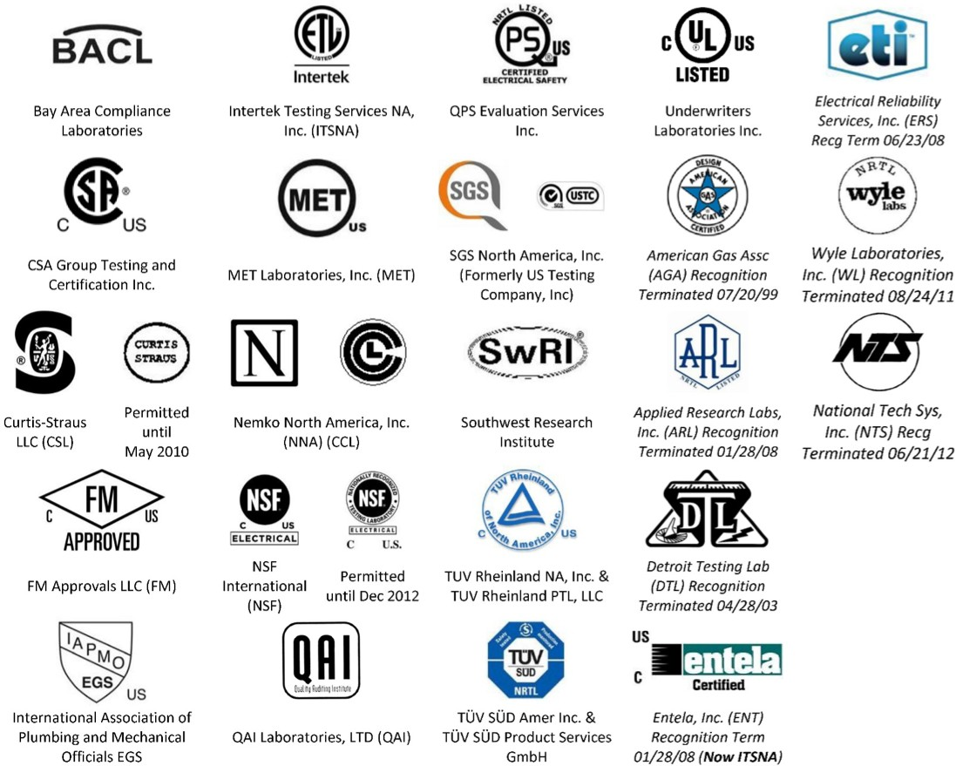

CONFORMITÉ EUROPÉENNE
CE is for European use. It is NOT accepted as an NRTL in the US, or at Argonne.

For the latest version of this list, check the ESH 377 course materials.
2

